**User Manual**

**[Gym Pod System]**

Diploma in Infocomm & Security

Academic Year 2023 Semester 2

| **Role** | **AdmNo** | **Name** |
| --- | --- | --- |
| Leader | 220274X | Olfsen |
| Member | 224700J | Mark Joseph |
| Member | 222836W | Pranav |
| Member | 222106N | Lucien |

#### Introduction

## Purpose

This document provides a step by step guide on how to set up the project environment and operate the different systems in our Gym Pod Application.

## Hardware

Raspberry Pi

Sensors Used :- RFID

Temperature Sensor

Sound Sensor

Ultrasonic Distance Sensor

Button

## Software

Visual Studio 2015

* Windows Iot Core
* Windows Form Application

.

## Environment Setup

Create Folder in Desktop

* C:\Users\[Username]\Desktop\FinalIoTProject

Database File is in FinalIoTProject\FinalDB\FinalIoTProject.mdf

Edit Windows Form App.config’s Connection String

* AttachDbFilename= C:\Users\[Username]\Desktop\FinalIoTProject\FinalDB\FinalIoTProject.mdf

Superuser Login

* Username : r00t
* Password: sup3us3r

User Login

* Username : Jeff
* Password: password

Sensor pin connections

RPISER – RFID

D4 – Push Button

D8 - Distance Sensor

A0 – Temperature Sensor

A2 - Sound Sensor

#### Database Design

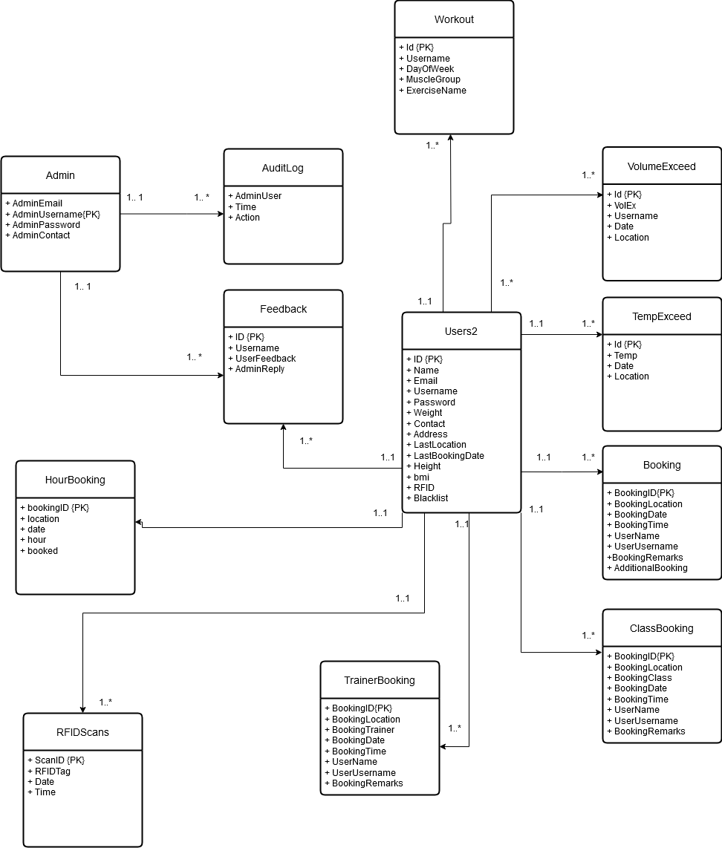

#### Gym Pod Admin Dashboard and Application

#### Description:

Gym Pod offers a private and personalised gym experience for users who want their own space to exercise. Each Gym Pod is a compact, fully-equipped workout space designed for one user at a time. The application allows for users to book gyms, trainers, and classes between the two gyms available, while allowing them to create and log their workouts based on muscle group. Personal information can be entered with insights like a forecast of a user's projected weight loss visualisation over time.

#### Login in as Superuser

**Purpose:**

The feature is used for superuser that does additional features like create/delete admins and view the audit log

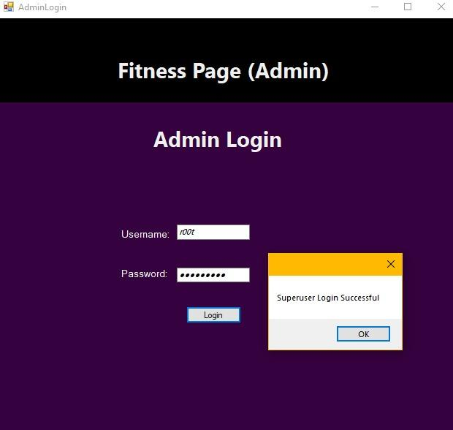

**How it works:**

* On load of the admin page
* Administrator will key in the details and click **Verify**. After verification, the new bus driver credentials will be added to the system database.

#### Create Regular Admin User

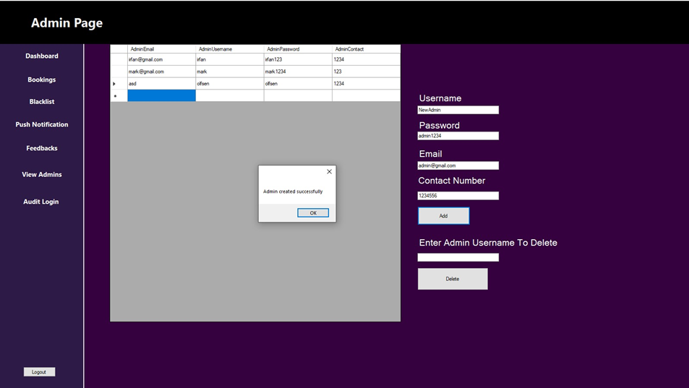

**Purpose:**

To allow Super user to add admins so that more admins can help to operate the system, making it easier for admins.

**How it works:**

* Super user will choose pick a username, password, email and their contact number, the username is unique hence it will check for duplicates, the super user also can delete admins if needed.

#### Main Dashboard

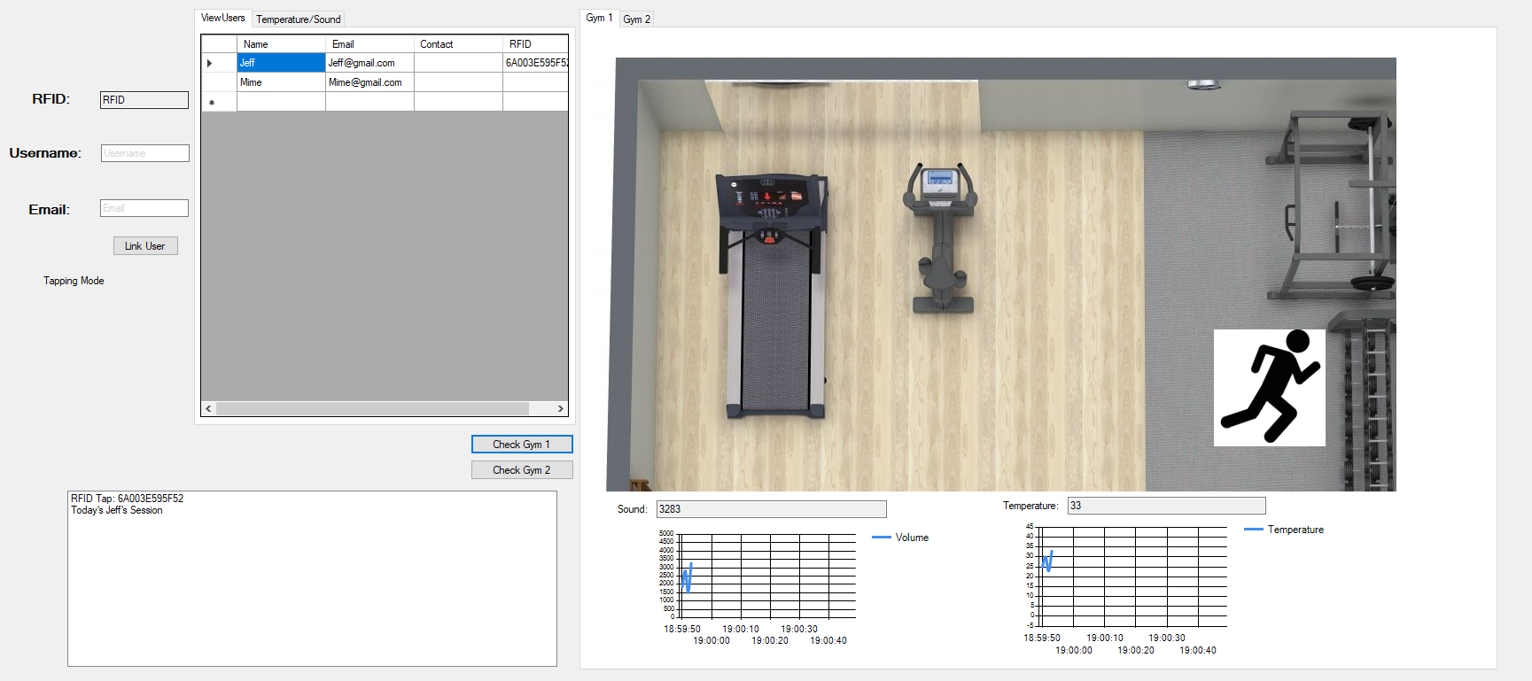

**Purpose:**

This is the main dashboard that the Admin sees when they log into the Application. The Main Dashboard is used for an Admin to gain insights following activities:

* View registered users and if they have been assigned an RFID
* View outputs from Temperature and Sound Sensor
  + A real time chart based on which session is being used by a valid user
  + Saved data based on threshold conditions
* View RFID output to see if its valid from a user, a known RFID card, or if the user has a booking within the valid time frame

**How it works:**

* Temperature and Sound sensor sends data to the Admin dashboard in real time, allowing an Admin to notice if the temperature inside the Gym Pod is getting too high or a user is misusing equipment and causing a lot of noise
* Registered users are obtained from the User registration page, where all credentials are tested before sent with exception of the RFID which must be done manually by an Admin

#### Main Dashboard (RFID Modes)

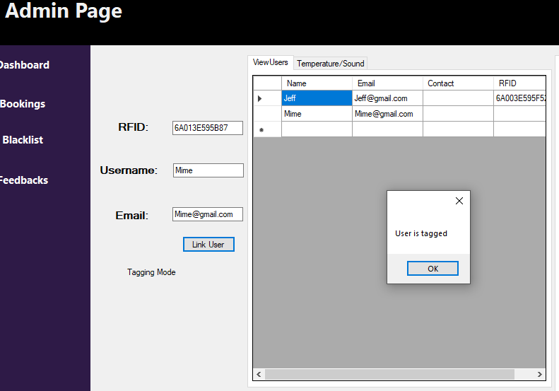

**Purpose:**

After a valid user has registered for Gym Pod, they need to be assigned an RFID to tap into the Gym Pods of their choosing. This component allows an Admin to also view who has not been assigned, and to update a current user’s RFID should they already have an existing RFID.

**How it works:**

* There are two modes in the RFID feature: Tagging Mode, and Tapping Mode. Tagging mode allows an Admin to tap an RFID onto the sensor and have its output displayed on the screen.
* From there, they’ll need to enter the username and Email of the user they wish to assign an RFID to
* If the user does not have an existing RFID, they’ll be tagged with a message box shown that the user has been tagged

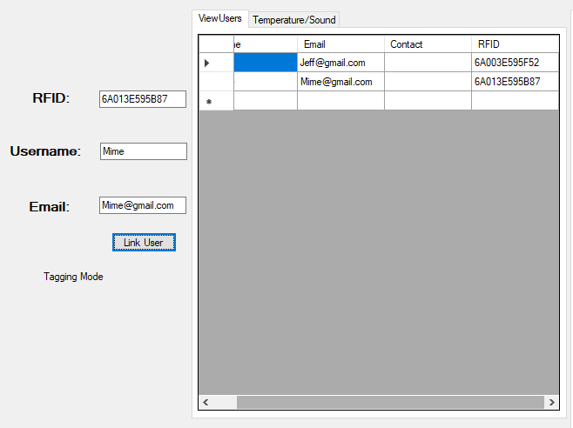

After the message box, the data grid view will be updated to show that the selected user has been given an RFID. From there, they’ll now be able to book sessions and enter the Gym Pod of their choice.

**How it works:**

* This is done by referring to the Database where users send their registered info and Admins can read them.
* From there, validation is done via checking for existing RFIDS.

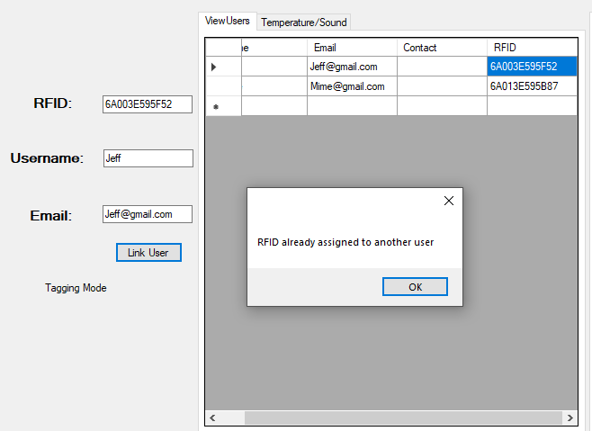

In the above instance, the user ‘Jeff’ already has an RFID tagged to them, the process is halted with an ‘Overwrite’ button becoming available in such situations.

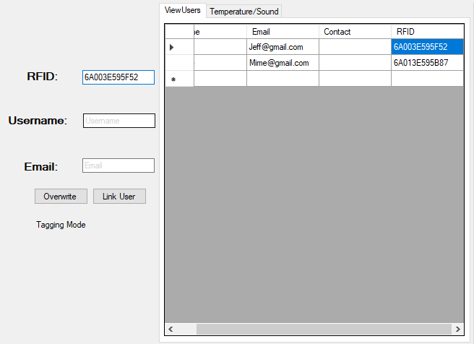

The overwrite feature allows an Admin to force an update of the user’s RFID. Once clicked, the user will have their RFID be updated.

#### Main Dashboard (RFID Mode) (contd.)

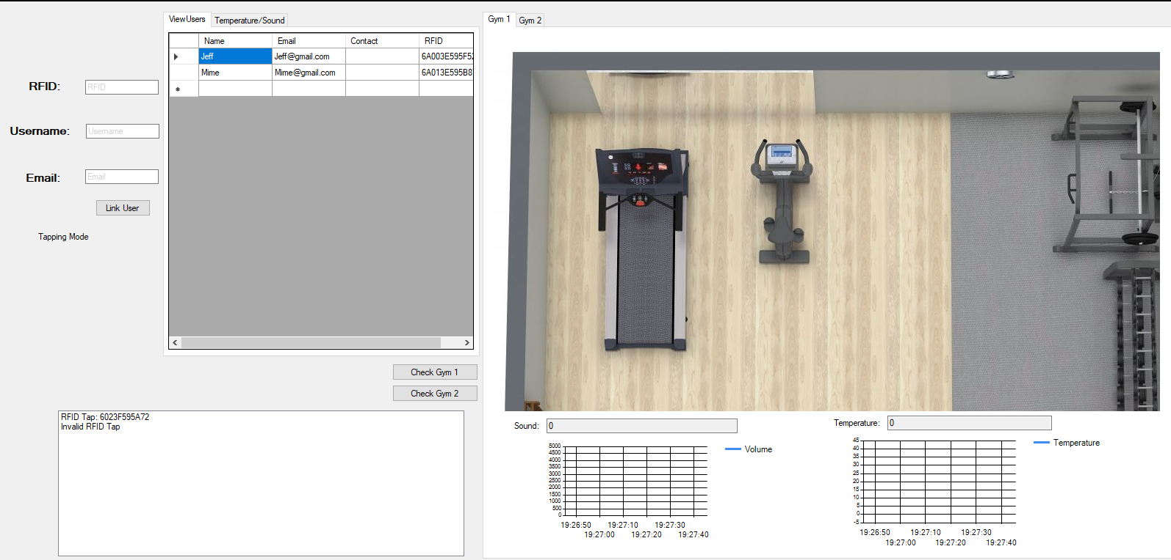

**Purpose:**

After having their RFID tagged, a user can now book sessions and use the Gym Pod. However, not all RFID taps are valid. The output box on the bottom left shows that a recent RFID has been tapped and that it’s unknown. Hence the message of ‘Invalid RFID Tap’.

**How it works:**

* This is done through the comparing of all known RFID registration done in the ‘Tagging Mode’
* The modes of Tagging and Tapping can be alternated from a short button hold,, with the text below the ‘Link User’ button displaying the current state.
* Validation is implement to check for the following:
  + If the RFID originates from the Registered Users table, and have an assigned RFID
  + If the RFID from a user contains a the valid booking date
    - Users who booked for their slot in the Gym Pod are checked for when was their booking date
    - If it was before the current time (i.e. they came early), they’d be allowed and the Temperature and Sound Sensors for the respective Gym Pod would begin sending data to the Winforms
    - If it was after the current time (i.e. they came late), it’ll be deemed as an invalid tap and the message ‘It’s not [username]’s session’ will show.

#### Main Dashboard (Sound)

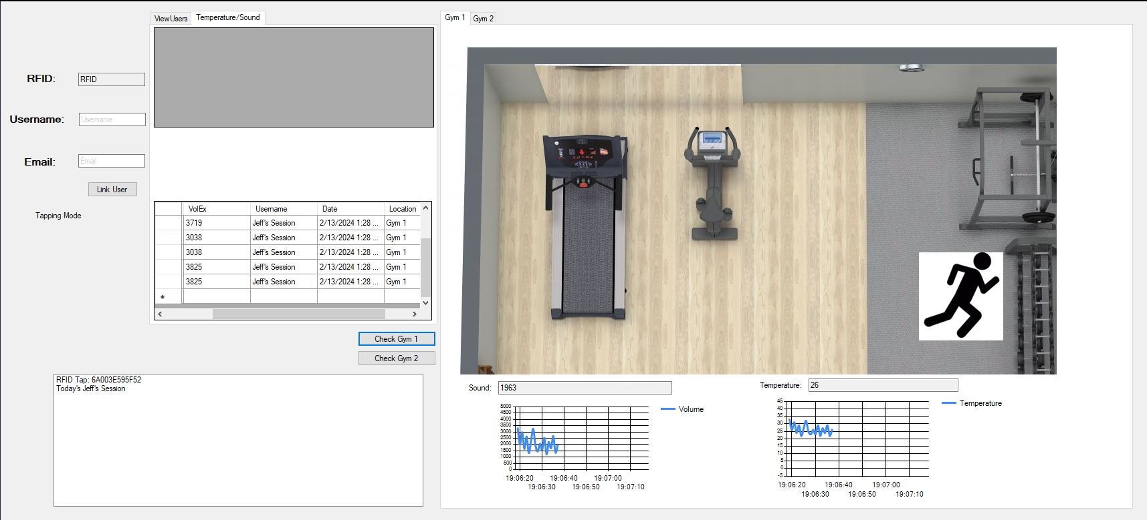

**Purpose:**

The use of the Sound Sensor is to keep track of the user’s volume from within the Gym Pod. An Admin who is looking at both chart and text box can gain insight with the former showing the pattern of a user during the session, while the latter displays a numerical value that is easy to understand.

**How it works:**

* Depending on the selected Gym Pod by the user, upon a valid tap that proves both the user’s identity and a valid booking will the Sound sensor in that specified Gym Pod begin sending data to the Windows Form. Gym 1 and Gym 2 can be alternated from the Tab Page element.

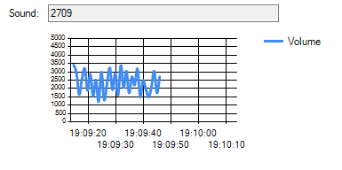

**Purpose:**

The real time visualization of the user’s volume is intended for the Admin who is looking at the chart to gain insight on the user’s past pattern of volume during their session in the Gym Pod. The displayed numerical value helps to easily understand the value of the volume that is captured by the Sound Sensor from the user’s activity.

A threshold condition of 3500 has been set where should the user exceed the volume, a message box will show up and alert the Admin that the user has made too much noise. This will then log the instance of the user exceeding the threshold, containing information like volume captured at the moment, who’s session was it, the date and time of the occurrence, and the location of the Gym.

**How it works:**

* Upon entry to the Gym Pod, the sensors of the gym would begin sending data to the winforms
* If the user does not exceed the threshold of 3500, the chart will continue plotting to show their volume during the session
  + If they exceed the threshold, the event would be logged in the database where Admins can view how many times have the user exceeded the threshold and can take action from the insight gained

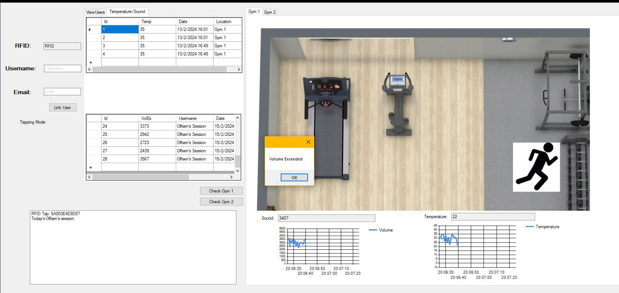

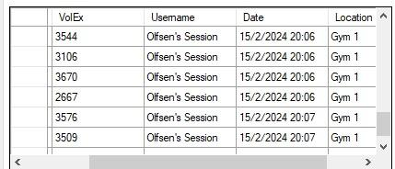

#### Main Dashboard (Temperature)

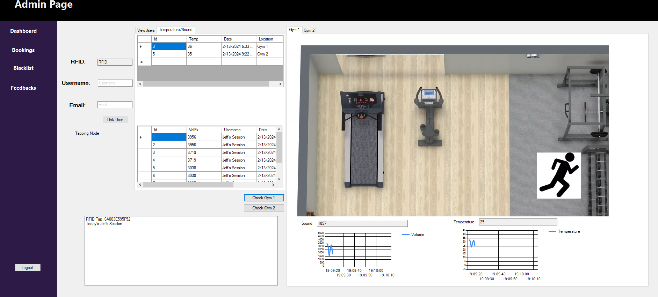

**Purpose:**

Thi implementation of the temperature into the Gym Pod was for both Admin and user to be aware of the changing temperatures inside the Gym Pods. For the Admin, they can see the temperature change in real time whenever a user is in the Gym Pod, and see that across a period of time, which time of day would have higher temperatures. Like the sound sensor, a threshold condition is also set, it will be logged on the Admin Dashboard, and an email will be sent to the user that the gym is too hot with the advice of drinking more water.

**How it works:**

* When a user begins their session at the chosen Gym Pod, the sensors will send data over to the winforms to be visualized
* The plotting of data onto the chart helps in understanding the recent temperatures of the Gym Pod during the session
* The displayed value helps with better understanding the plotted information in real time
* If the temperature exceeds the threshold of 35 degrees, a messagebox will show to alert the Admin that the temperature in that Gym Pod is too high
  + The information will then be logged containing details like the recorded temperature, the date and time of the occurrence, and the location where it was recorded.
* When the threshold has been exceeded, an email is also sent to the user in the Gym Pod with a message containing information on the recorded temperature together with the date and time. It’ll also contain advice like drinking more water for the user’s safety.

#### 

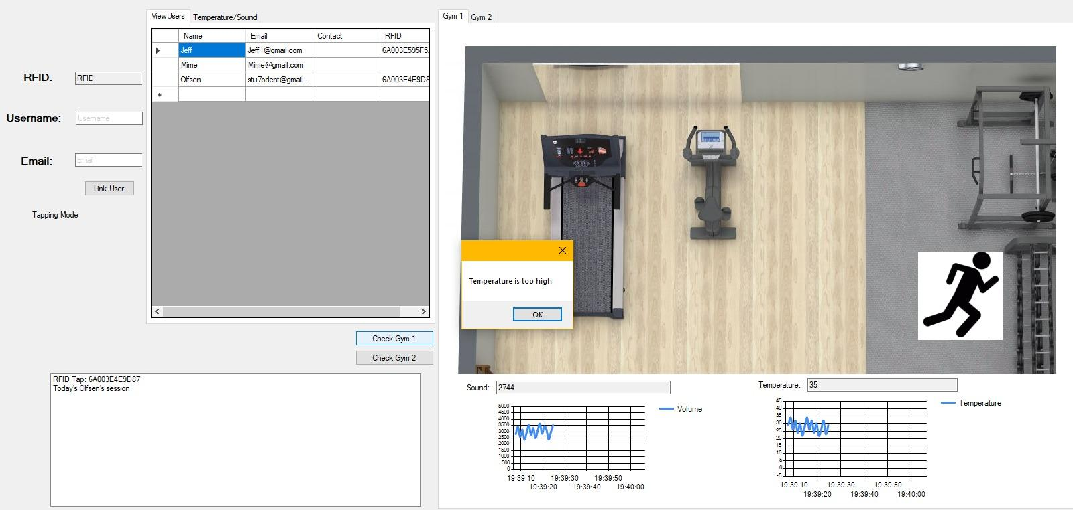

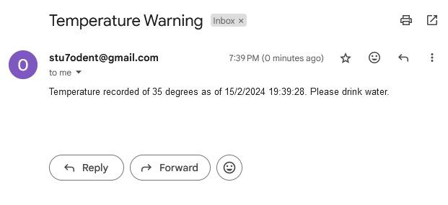

#### Main Dashboard(Distance Sensor)

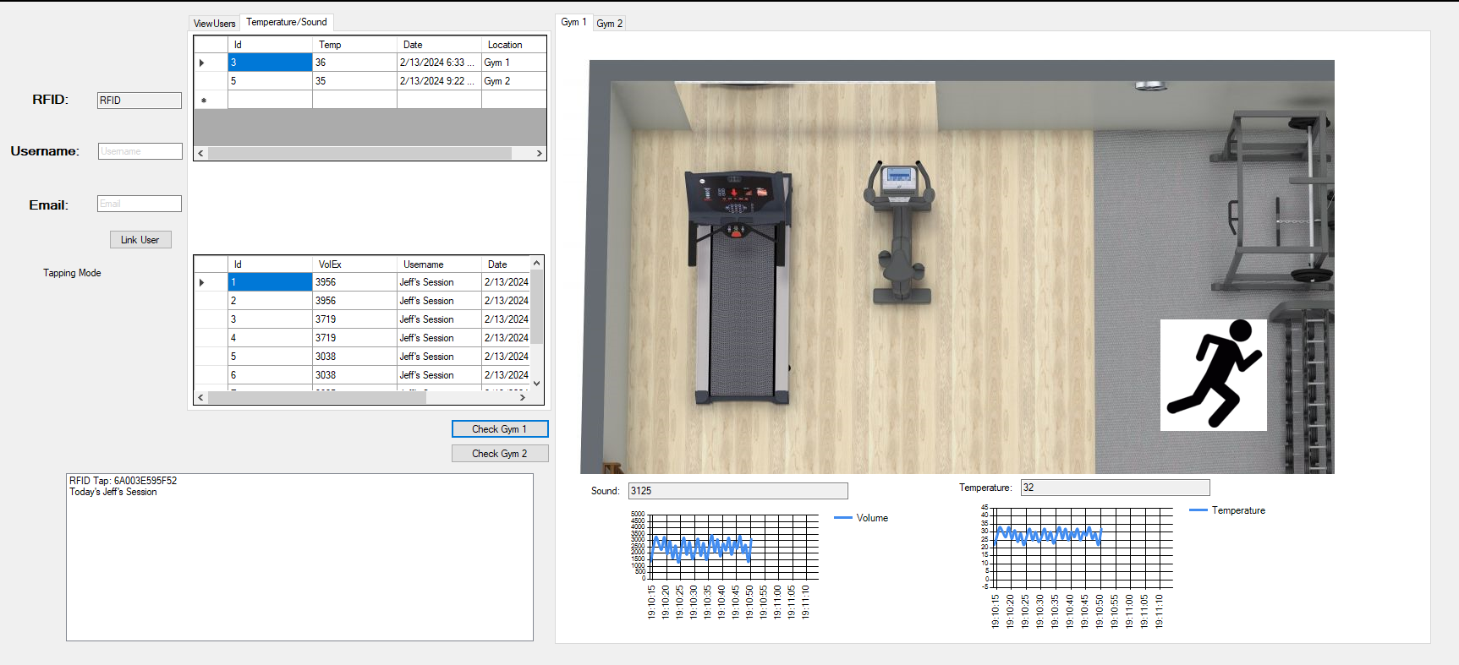

**Purpose:**

As part of understanding users, the Distance sensor was implemented to track the movements of the user within the Gym Pod. Given that there are two distinct sections, the weights and cardio section, the user would alternate between these two zones and as an Admin looking at the image of where the user is at that moment, insights can be gained on which set of equipment is more preferred.

**How it works:**

* Upon entry, the default state of the zone shown is the weights section.
  + From there the user can alternate between the two sections
* A condition is set on the Distance sensor where when a user is a certain distance close to the sensor, it is believed that they have entered another zone, and the image will change to reflect that the user has now entered the cardio section of the Gym Pod.
* When the user is done, they can leave the cardio zone for the weights. As the condition set is constantly checking if the user is close enough to be considered in the cardio section, when they leave it for the weights, the condition of them being there is no longer met, and the image will shift to show the change in state that the user is now in the weights section.

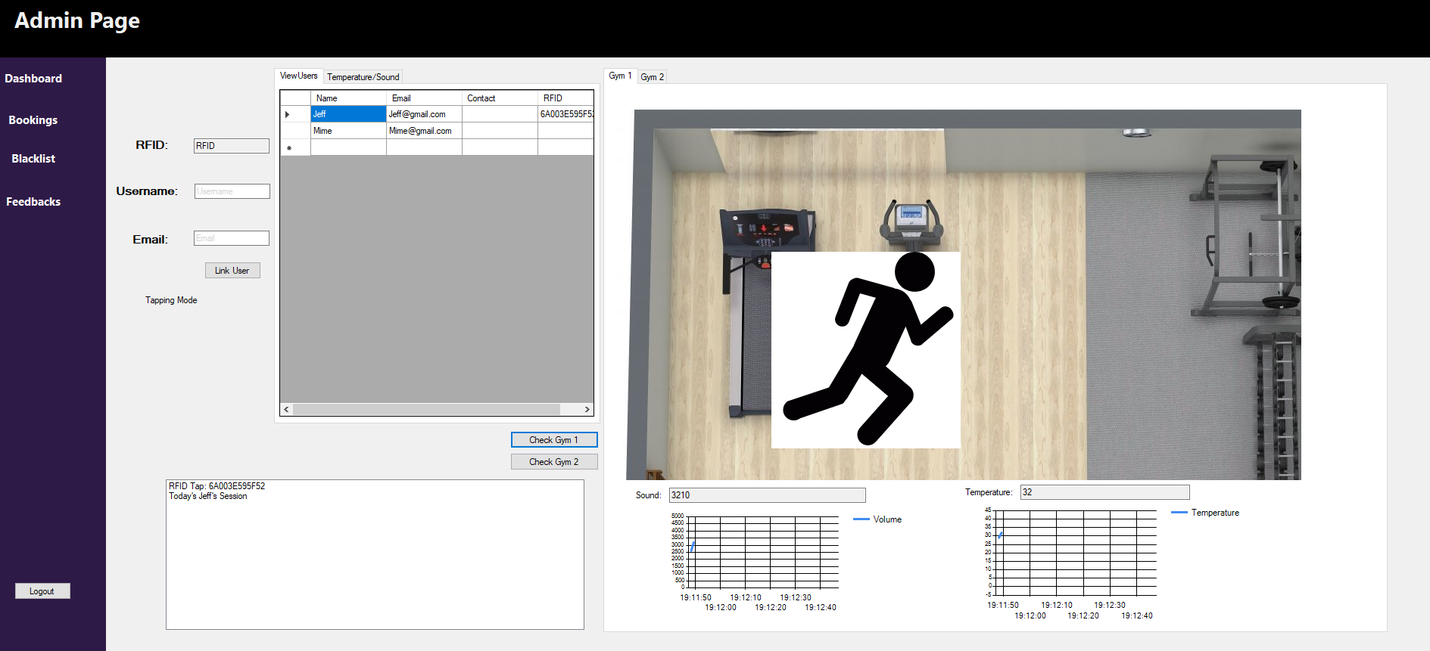

#### 4. Audit Log

#### 

**Purpose:**

The purpose of an audit log feature is to track and record all actions and events within a system or application. It serves as a detailed historical record for accountability, compliance, and troubleshooting purposes.

**How it works:**

* When an Admin logs in, it will save a session and will track what time the admin login and who is the Admin.

#### 5. Blacklist System

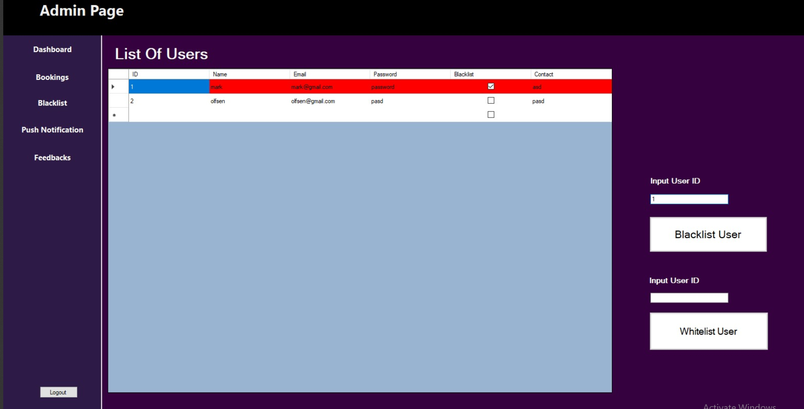



**Purpose:**

Admins are able to restrict user access into the application if the user has broken certain rules. admins can also whitelist user if they are deemed OK to access the system

**How it works:**

* Admins would be able to view a list of users from the table, from the table the Admins will read specific user’s ID and key the ID into the textbox, the user will then be able to blacklist or whitelist a user, when a user is blacklisted the row will turn red.

#### 6. Feedback System

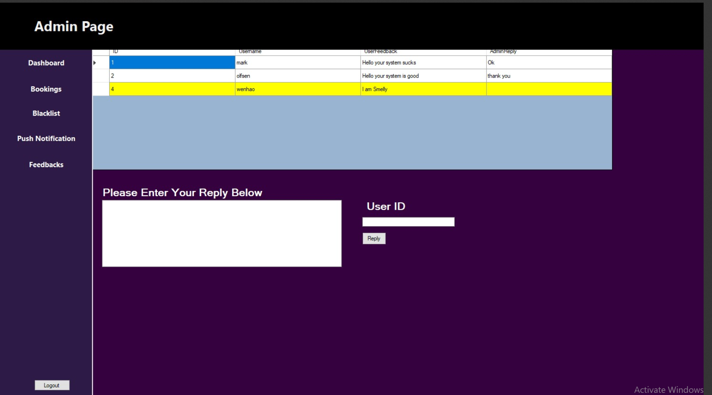

**Purpose:**

Users are able to feedback to the admin to express what they want to say and the admins are able to read the feedback and make improvements.

**How it works:**

* Admins will read the table that contains the User ID, name and their feedback, it is filtered such that the table will only show the user that has a feedback, when there’s a feedback and no admin reply, the row will be highlighted in yellow, the admin just have to key the user ID and the feedback and it will update the table such that the admin reply will be inserted into the table.

# Gym Pod User Dashboard and Application

##### Description:

Gym Pod offers a private and personalised gym experience for users who want their own space to exercise. Each Gym Pod is a compact, fully-equipped workout space designed for one user at a time. The application allows for users to book gyms, trainers, and classes between the two gyms available, while allowing them to create and log their workouts based on muscle group. Personal information can be entered with insights like a forecast of a user's projected weight loss visualisation over time. Users can also track their entries to the gym regularly and they alter their personal information like email and password.

# UserEntry Pages

#### Register a New User

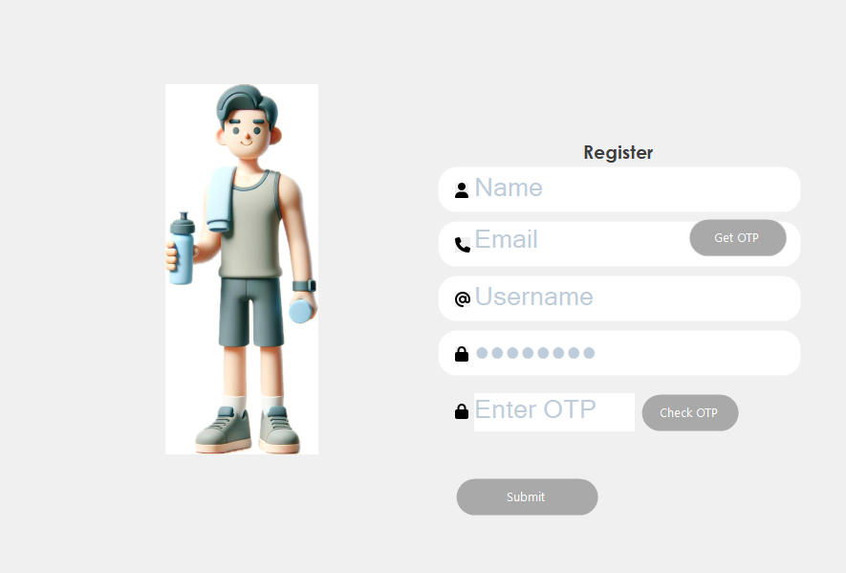

##### **Purpose:**

New Users can register themselves to the user application so that they can access tools that are provided in the application.

##### **How it works:**

* Users will first open the User Register page and then they will be asked to enter their details like Name, Email, Username and Password. They will also be asked to verify their email via email otp, so they have to click the ‘Verify OTP’ button beside the textbox to enter their email and they will receive an email with the OTP and they have to enter it in the ‘Enter OTP’ textbox. Afterwards, they need to click the ‘Verify OTP button which will verify then only will be they allowed to log in.
* the register page will also check to see for duplicate user registrations through the username.

#### Login a User

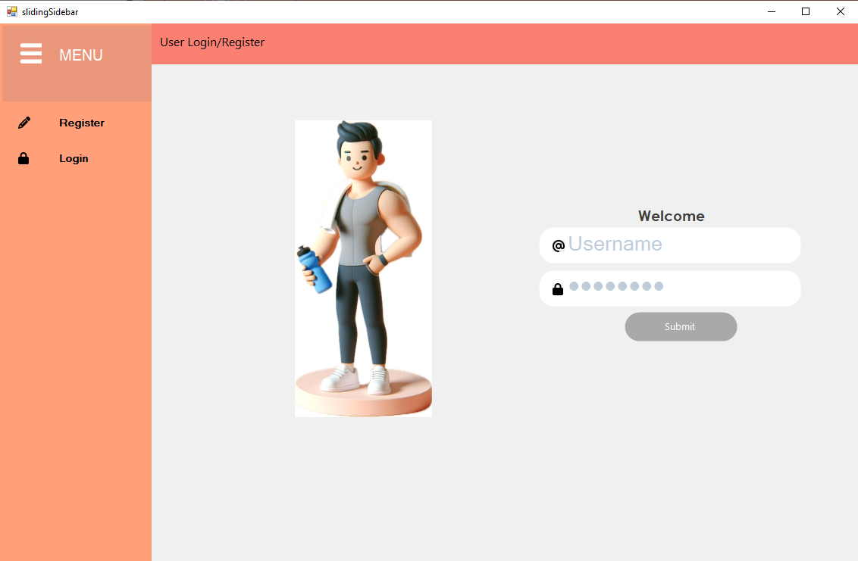

##### **Purpose:**

Users can Login, using the details they used to register, to the user application so that they can access tools that are provided in the application.

##### **How it works:**

* Users will have to enter their created Username and Password to login.
* The login page checks to see if the details entered are valid, if details are invalid it will say that the login details are invalid
* The login page also checks to see if a user that is trying to login is blacklisted, if they are a, the message displayed will be that they are currently not allowed to log in.
* if login is successful, the homepage will be shown.

# User HomePages

#### Home Page

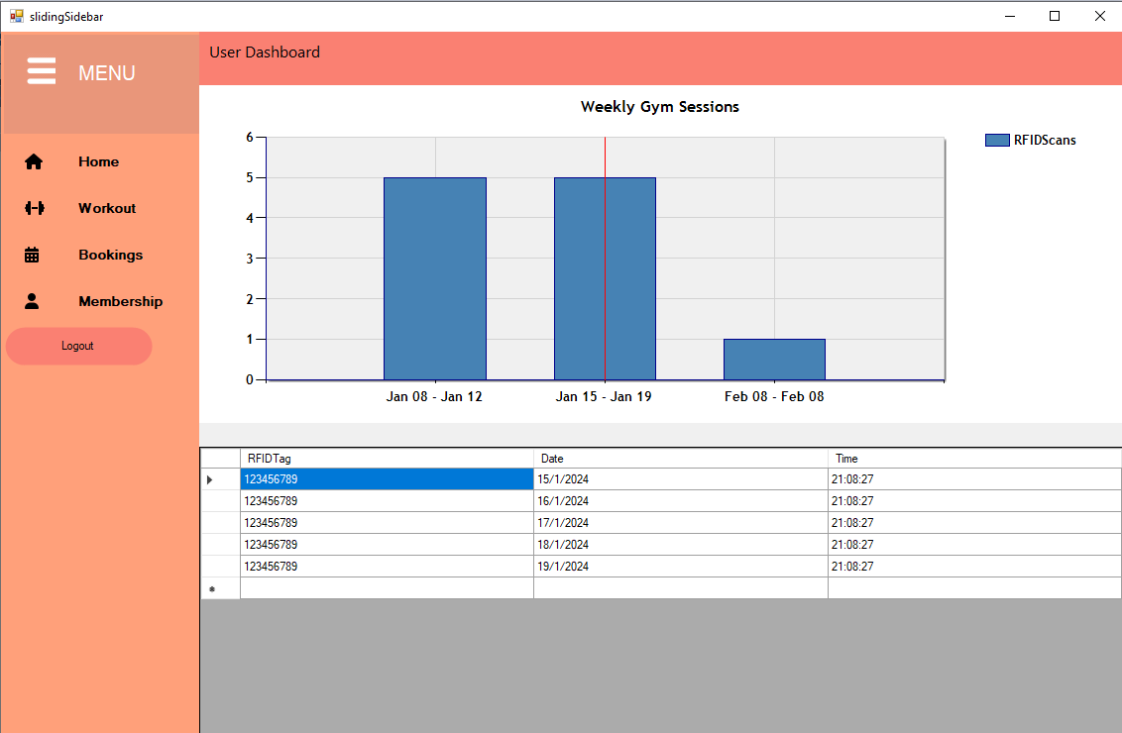

##### **Purpose:**

Users can view their number of entries in a weekly basis in a bar chart format

##### **How it works:**

* Users can only see their chart if they have a valid RFID Tag linked to them.
* The bar chart is displayed in weekly format, where the x-axis are the dates of a week and the y-axis is the number of entries.
* The chart is updated live from the database.
* The chart is interactive where the can click one of the bars to view the exact dates and times that they went to the gym
* The chart only counts all RFID Scans of one day as one entry to the gym.

#### Booking Page

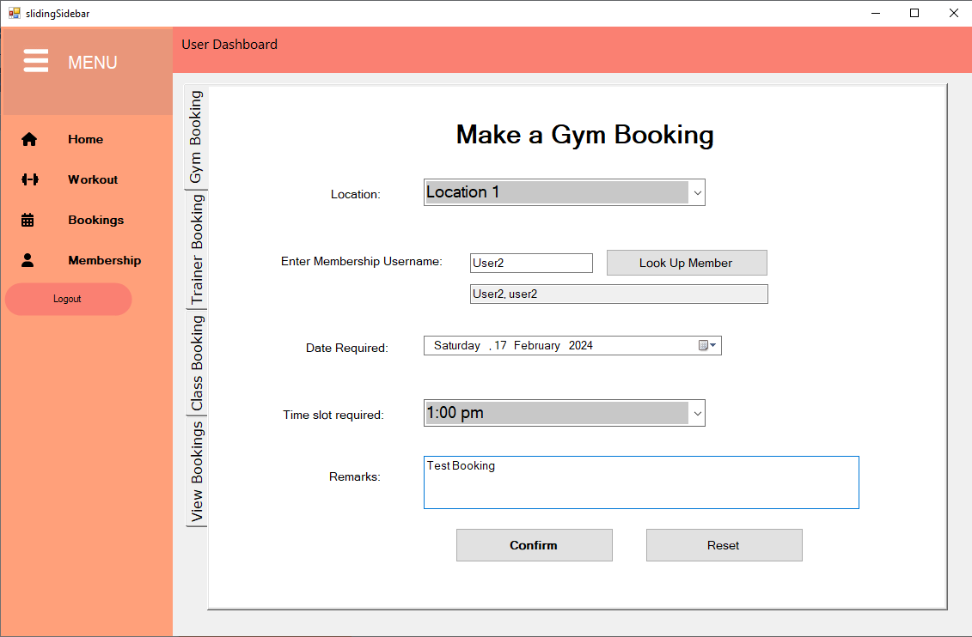

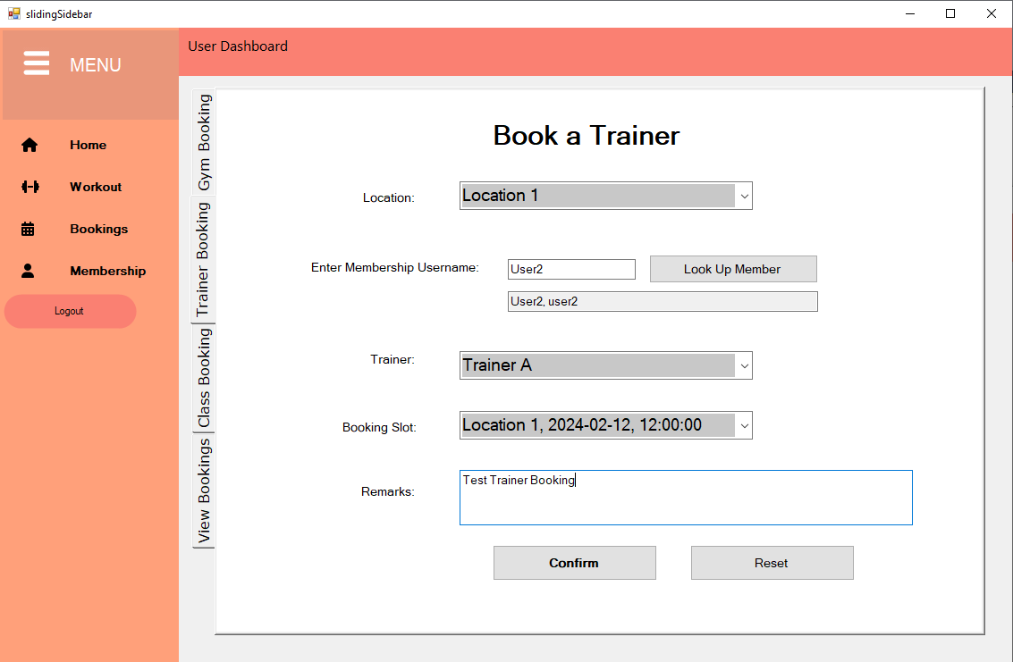

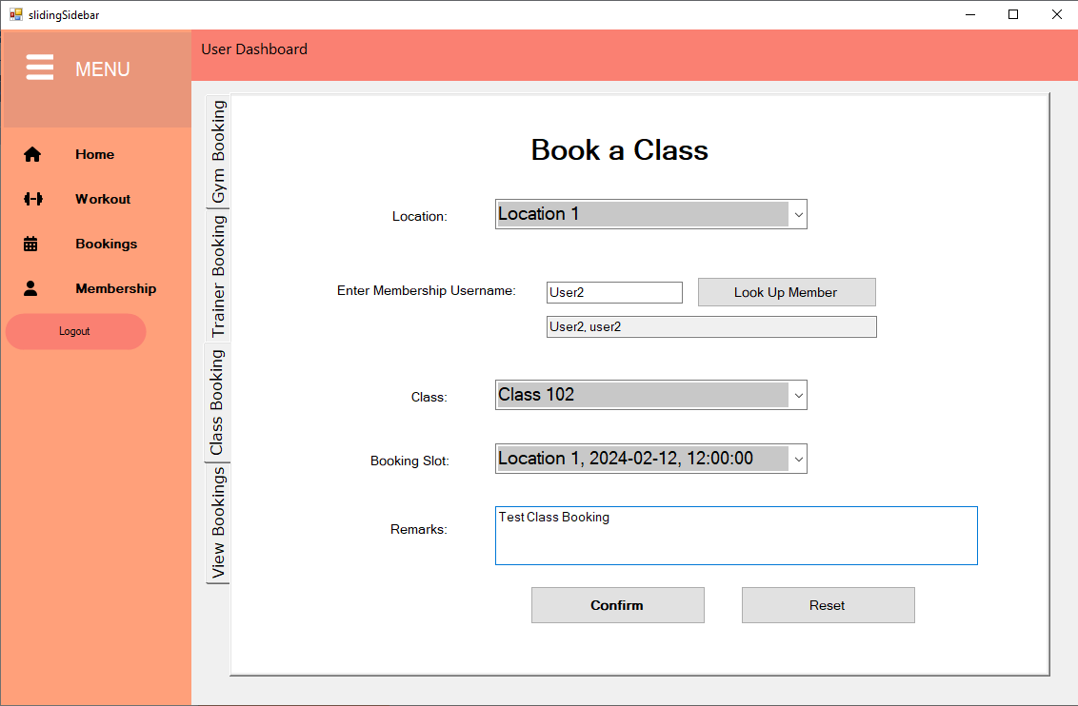

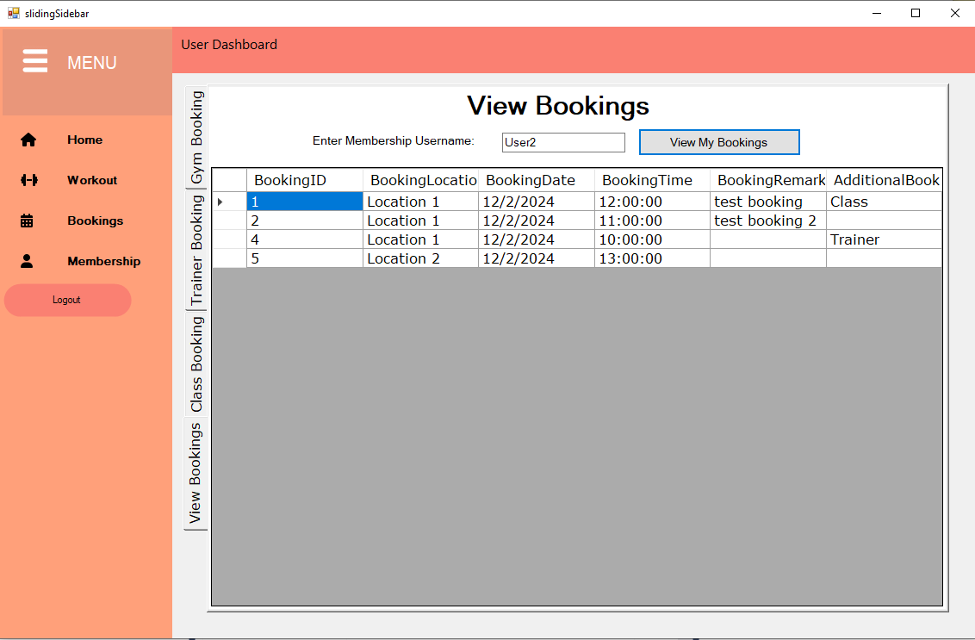

##### **Purpose:**

Users can book gym slots and then carry on to book a trainer or a class for that specific gym slot that the users have booked. They can also view all their bookings under the ‘View Bookings’ tab.

##### **How it works:**

* Users will first need to create a gym booking by selecting a location, entering their username and searching it up in the database, selecting their preferred date, selecting which time slot they wish to use the gym and adding any remarks for the booking if needed.
* Once a time slot has been booked, no other user can book the same time slot.
* There are other booking tabs that are available which are the Trainer Booking and the Class Booking.
* The additional bookings are only available for users if they have a present Gym booking. they will be asked to select the location which will filter the classes and trainers for each location as they are unique. then users need to enter their username and search the database for it so that it can populate the time slot combo box with the user’s gym bookings which they have to select. Users are also required to select the trainer or class they wish to book and add any remarks if needed.
* Users that have a gym booking and have booked a trainer for that gym booking, are not allowed to book any other additional sessions for that time slot like a class and vice-versa.
* Users can also view all their bookings that they made together with whether there is and additional booking to that or not.

#### Workout Page

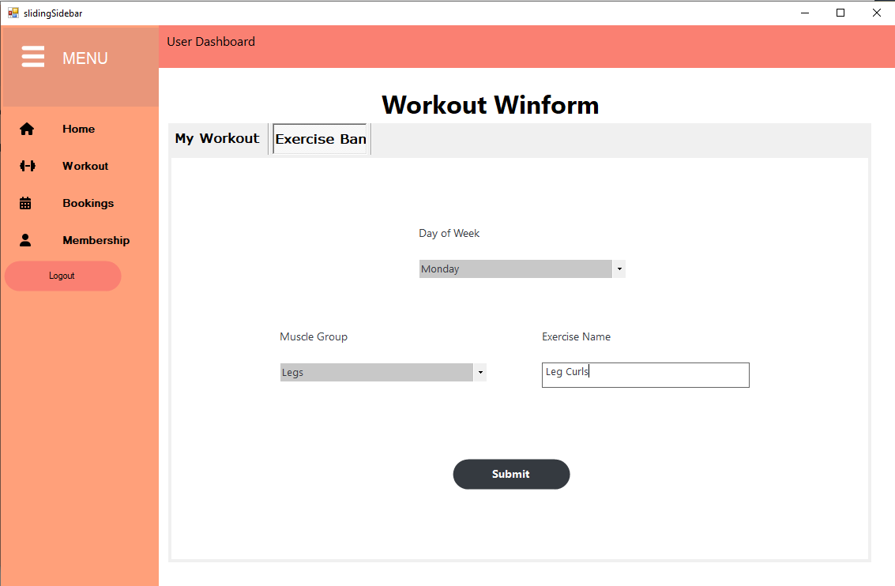

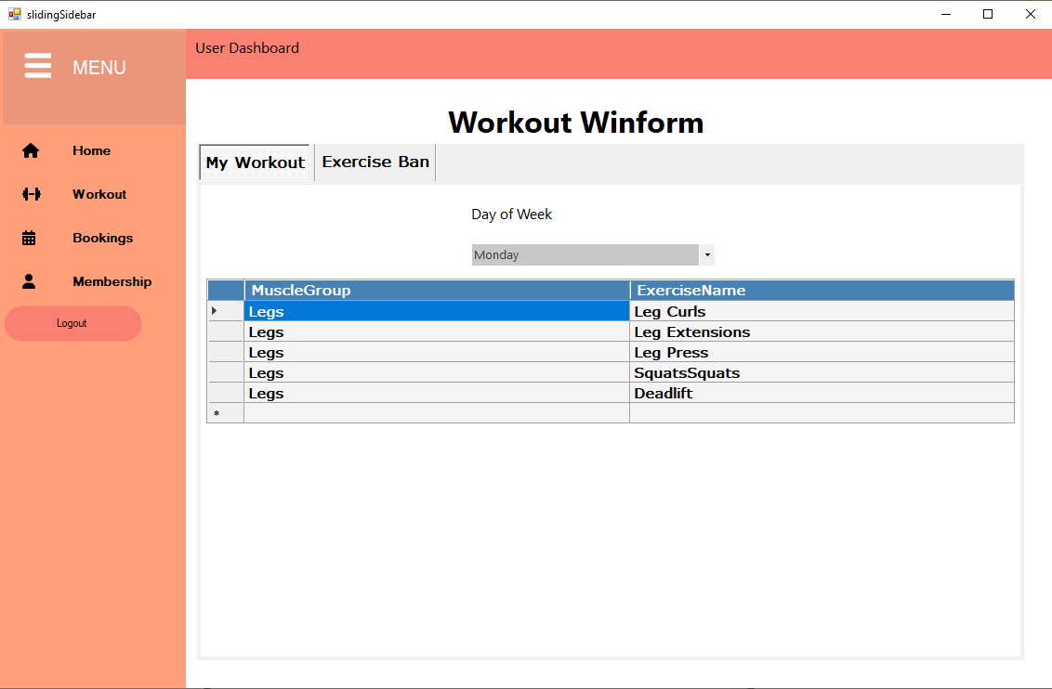

##### **Purpose:**

Users can create their specific weekly workout plan and manage it for greater convenience

##### **How it works:**

* Users will first select the day of week, select the muscle group they are targeting and then enter the name of the exercise. Then they will submit it, saving it to the database.
* In the view exercise tab, the user can select the day of week and a table with all the exercises saved will be shown with the targeted muscle group and the name of the exercise.
* This page is user-specific, meaning that the user can only view their own exercises and only create for themselves.

#### Membership Page

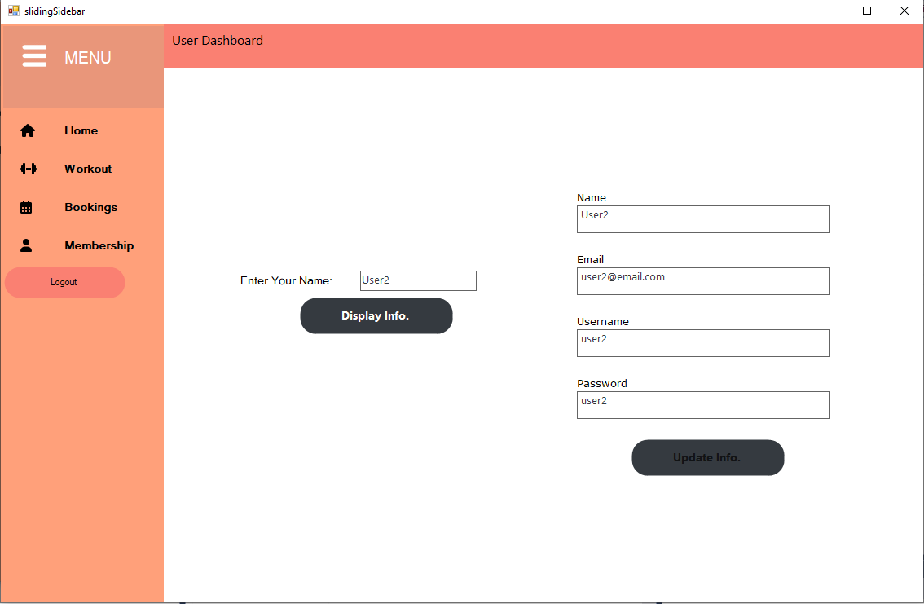

##### **Purpose:**

Users can alter their information under this page.

##### **How it works:**

* Users will first have to enter their username and search it in the database, which will display their name, email, username and password in the display textboxes.
* Users are allowed to change their email and password only in case they forgot or they need to update it.

##### 

#### BMI Calculator

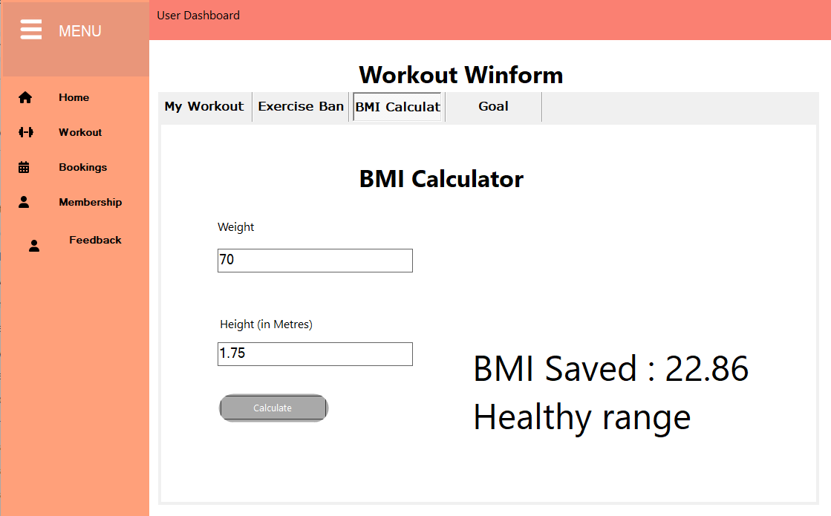

**Purpose:**

Users can find out their bmi and it can provide a general idea of whether a person is underweight, normal weight, overweight, or obese.

##### **How it works:**

* Users will enter their Weight and Height to get their BMI.
* Users will then see their BMI and a message that tells them their BMI Status, whether overweight, underweight, or healthy./
* Users would then have their BMI, Height and Weight saved into the database for retrieval.
* Users would then be able to retrieve their Weight and BMI for reassessment and for goal settings./

#### Feedback Page

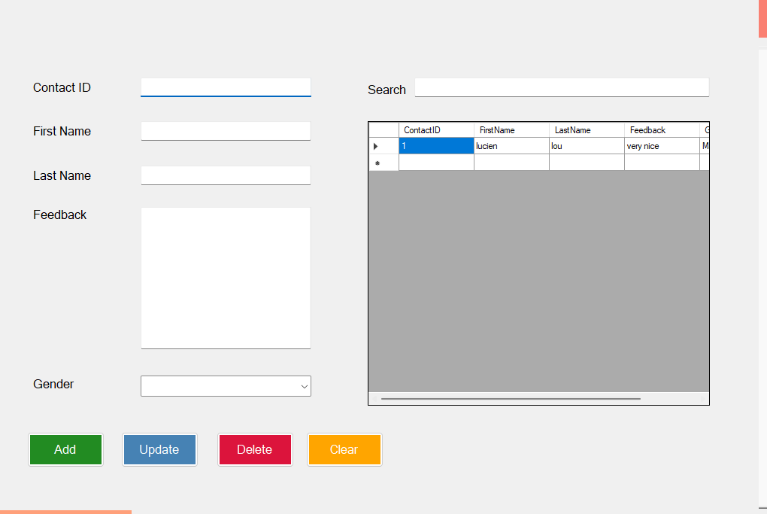

**Purpose:**

Users are able to feedback to the admin to express what they want to say and the admins are able to read the feedback and make improvements.

**How it works:**

* Users would enter their Username, their feedback and their gender.
* Users would have their feedback saved to the database which would display to other users
* Other users can see the feedback of others
* Admins will read the table that contains the User ID, name and their feedback.
* The Admin will then be able to reply to user’s feedback
* The Admin reply will be displayed in for the users to see, and if the user’s feedback does not have a reply from the Admin, the portion of the part containing Admin Reply will be blank.

1. **Goal Setting**

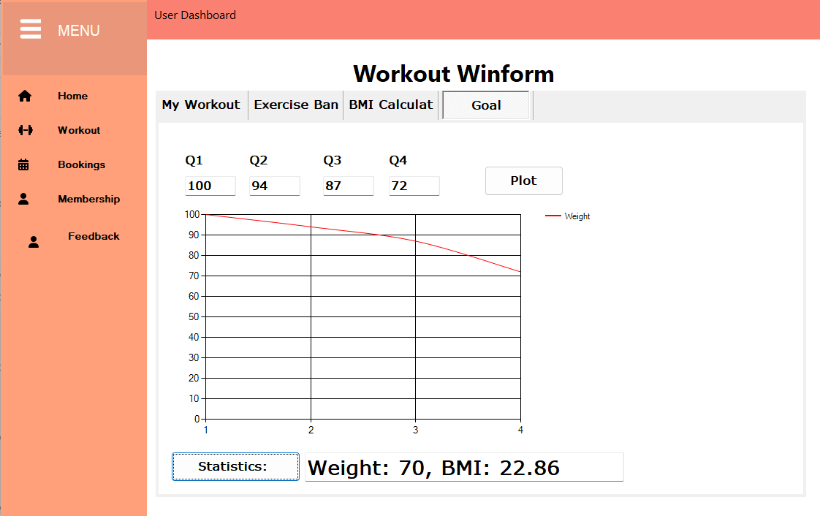

**Purpose: Users would be able to enter their ideal weight and their goal over a course of the four quarters of the year.**

**How it works:**

* Users would enter the ideal weight of the course of the year in quarters
* A graph of their weight gain or loss would be plotted
* Users would get to visualise their progress over a course of a year and make necessary precaution from this plotted graph
* Users would also be able to retrieve their current weight and bmi as entered from the BMI calculator to see their current standing against their projected.